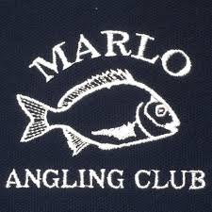
MARLO ANGLING CLUB
SOUVLAKI DINNER
Friday 3rd of February
6.00pm at the clubrooms on Foreshore Rd Marlo
ADULTS:
Lamb/chicken/vegetarian with chips $15
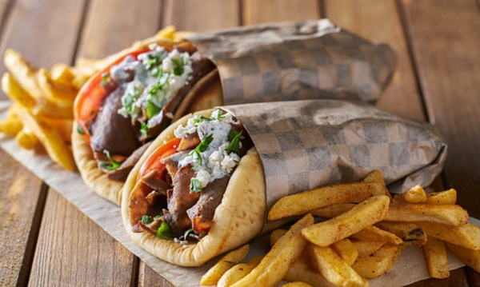
KIDS:
Box of chips $6
Cup of chips & 3 nuggets $4
Kids’ souvlaki & chips $8

Raffles
BAR SERVICES (no byo)
All welcome!

